Motion and Force in a Gravitational Field

Revision Problems 2: Projectiles Due: ________________________

Name: ________ ANSWERS ______________ (20 marks)

- Ben and Oren are riding in a hot-air balloon which is ascending at 4.50 ms⁻¹. When the balloon is 1.50 x 10² m above the ground, Ben’s sunglasses fall off and freefall to the ground. Assuming no air resistance, with what velocity do the sunglasses hit the ground? You must draw a labelled diagram with your answer. (3 marks)

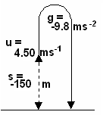
v_{v}² = u_{v}² + 2gs
= 4.50² + (2 x -9.8 x -150) [1 mark]
= 20.25 + 2940
= 2960.25
v_{v} = 54.4 ms⁻¹ [1 mark]

[1 mark]

- Late one night, Joy Riders steal a car and when finished with it, drive it off a cliff. If the cliff is 25.0 m high and the car is driven off at 90.0 kmh⁻¹, how far from the edge of the cliff does the car hit the ground? (4 marks)

90.0 kmh⁻¹ = 25.0 ms⁻¹ [1 mark] s_{v} = u_{v}t + ½ gt²
-25 = 0 + (-4.9t²) [1 mark]
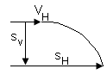
V_{H} = u_{H} = 25.0 ms⁻¹ 25 = 4.9t²
u_{V} = 0 ms⁻¹ t = 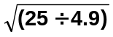
s_{v} = -25.0 m t = 2.26 s [1 mark]
g = -9.8 ms⁻²
s_{H} = v_{H} x t
= 25 x 2.26
s_{H} = 56.5 m [1 mark]

- Clayton is helping a farmer to drop hay onto the centre of a small island where some sheep have been stranded during a flood. He knows that a particular tree is exactly 3.50 x 10² m from the centre of the island and that the plane will be flying 2.00 x 10² m above the ground. At what horizontal velocity must the plane be travelling if he drops the hay out when he is above the tree? (2 marks)

s_{v} = u_{v}t + ½ gt²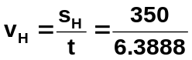
-200 = 0 + (-4.9t²)
200 = 4.9t²
t = 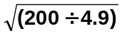 v_{H} = 54.8 ms⁻¹
t = 6.3888 s [1 mark]
s_{v} = -200 m [1 mark]
s_{H} = 350 m
g = -9.8 ms⁻²

- A basketball is shot up into the air at 8.00 ms⁻¹ and comes down to pass through a basket ball hoop to score the winning point. If the ball is released 1.40 m above the ground at an angle of 52.0⁰ to the horizontal and passes through the hoop at a vertical height of 3.10 m above the ground, how far was the player from the basketball post. (Do not use solver for this question and show all working for full marks.) (5 marks)

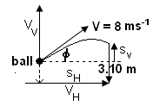
v_{v}² = u_{v}² + 2gs
= 6.30² + (2 x -9.8 x 1.7)
= 3.37
v_{v} = 2.524 ms⁻¹ down [1 marks]

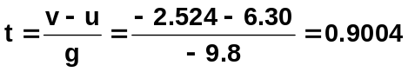[1 mark]

V_{v} = u_{v} = 8 sin 52 = 6.30 ms⁻¹ s_{H} = u_{H} x t
v_{v} top = 0 ms⁻¹ = 4.925 x 0.9004
V_{H} = u_{H} = 8 cos 52 = 4.925 ms⁻¹ s_{H} = 4.43 m [1 mark]
g = -9.8 ms⁻²
s_{v} up = 3.10 – 1.40 = 1.7 m
[2 mark for values]

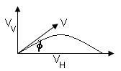
- Daniel has arrived early for a P.E. class and is killing time by throwing a tennis ball into the air. For one particular throw, Daniel throws the ball with an initial velocity of 4.30 ms⁻¹ at an angle of 68.0⁰ to the horizontal. The ball follows an arched path and is caught by Matthew. Assuming the ball was caught at the same height it was thrown, how far away was Matthew? (3 marks)

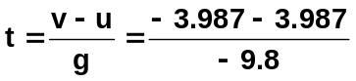 [1 mark]

t = 0.814 s [1 mark]

V_{v} = u_{v} = 4.30 x sin 68 = 3.987 ms⁻¹ s_{H} = v_{H} x t
v_{v} = -3.987 ms⁻¹ = 1.611 x 0.814
V_{H} = u_{H} = 4.30 x cos 68 = 1.611 ms⁻¹ s_{H} = 1.31 m [1 mark]
g = -9.8 ms⁻²

- Emma throws a ball from the top of one building towards a tall building 5.2 m away. The initial velocity of the ball is 6.00 ms⁻¹, 40.0⁰ above the horizontal. How far above or below its original level will the ball strike the opposite wall? (3 marks)
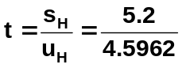
s_{H} = 15.2 m
u_{v} = 6 sin 40 = 3.8567 ms⁻¹
u_{H} = 6 cos 40 = 4.5962 ms⁻¹ t = 1.1314 s [1 mark]
g = -9.8 ms⁻²
s_{v} = u_{v}t + ½ gt²
= (3.8567 x 1.1314) + (-4.9 x 1.1314²)
= 4.3635 – 6.2723
= -1.91 m [1 mark]
negative sign indicates downwards so
ball strikes 1.91 m below original position.
[1 mark]

